WAP to simulate the working of a queue of integers using an array. Provide the following operations: Insert, Delete, Display The program should print appropriate messages for queue empty and queue overflow conditions

#include <stdio.h>
#define MAX 5 // maximum size of queue
int queue[MAX];
int front = -1, rear = -1;
void insert() {
int item;
if (rear == MAX - 1) {
printf("Queue Overflow! Cannot insert element.\n");
} else {
printf("Enter the element to insert: ");
scanf("%d", &item);
if (front == -1) // first element
front = 0;
rear++;
queue[rear] = item;
printf("Inserted %d into the queue.\n", item);
}
}
void delete() {
if (front == -1 || front > rear) {
printf("Queue Underflow! Queue is empty.\n");
} else {
printf("Deleted element: %d\n", queue[front]);
front++;
// Reset queue if empty after deletion
if (front > rear) {
front = rear = -1;
}
}
}
void display() {
if (front == -1) {
printf("Queue is empty.\n");
} else {
printf("Queue elements are: ");
for (int i = front; i <= rear; i++) {
printf("%d ", queue[i]);
}
printf("\n");
}
}
int main() {
int choice;
while (1) {
printf("\n--- Queue Menu ---\n");
printf("1. Insert\n");
printf("2. Delete\n");
printf("3. Display\n");
printf("4. Exit\n");
printf("Enter your choice: ");
scanf("%d", &choice);
switch (choice) {
case 1:
insert();
break;
case 2:
delete();
break;
case 3:
display();
break;
case 4:
return 0;
default:
printf("Invalid choice! Try again.\n");
}
}
}

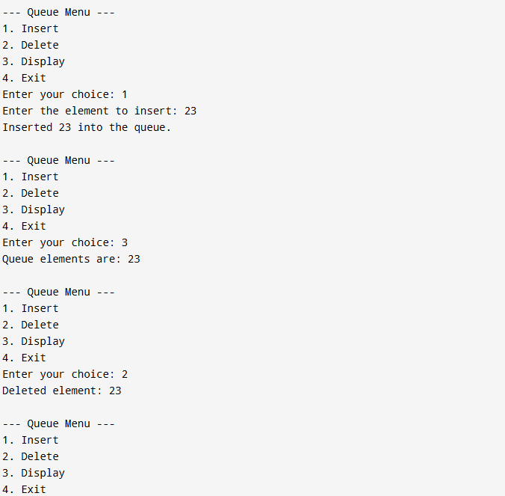

WAP to simulate the working of a circular queue of integers using an array. Provide the following operations: Insert, Delete & Display The program should print appropriate messages for queue empty and queue overflow conditions

#include <stdio.h>
#define MAX 5 // size of circular queue
int queue[MAX];
int front = -1, rear = -1;
void insert() {
int item;
// Check for queue full condition
if ((front == 0 && rear == MAX - 1) || (rear + 1 == front)) {
printf("Queue Overflow! Circular Queue is full.\n");
return;
}
printf("Enter element to insert: ");
scanf("%d", &item);
// First element insertion
if (front == -1) {
front = rear = 0;
} else {
rear = (rear + 1) % MAX;
}
queue[rear] = item;
printf("Inserted %d into the queue.\n", item);
}
void delete() {
if (front == -1) {
printf("Queue Underflow! Circular Queue is empty.\n");
return;
}
printf("Deleted element: %d\n", queue[front]);
// Only one element
if (front == rear) {
front = rear = -1;
} else {
front = (front + 1) % MAX;
}
}
void display() {
if (front == -1) {
printf("Queue is empty.\n");
return;
}
printf("Circular Queue elements: ");
int i = front;
while (1) {
printf("%d ", queue[i]);
if (i == rear)
break;
i = (i + 1) % MAX;
}
printf("\n");
}
int main() {
int choice;
while (1) {
printf("\n--- Circular Queue Menu ---\n");
printf("1. Insert\n");
printf("2. Delete\n");
printf("3. Display\n");
printf("4. Exit\n");
printf("Enter your choice: ");
scanf("%d", &choice);
switch (choice) {
case 1:
insert();
break;
case 2:
delete();
break;
case 3:
display();
break;
case 4:
return 0;
default:
printf("Invalid choice! Try again.\n");
}
}
}
